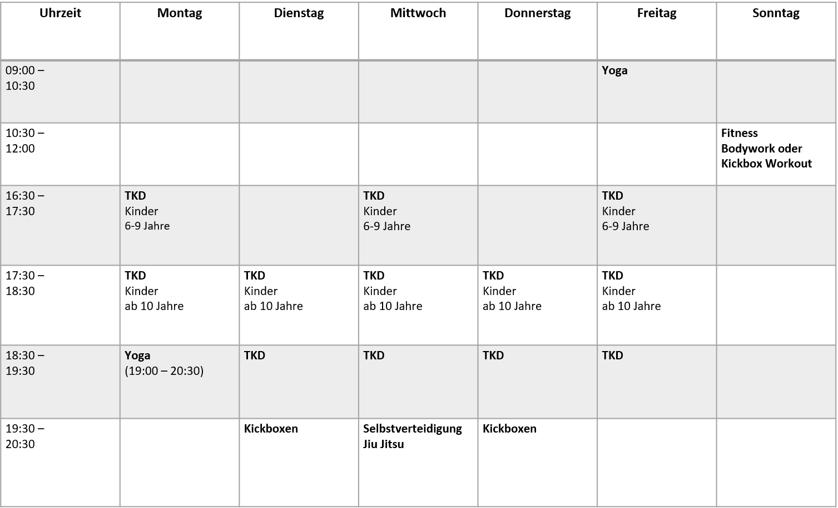

Stundenplan  
**ab September 2021**